Name: Dylan Renard

Biostatistics Final Exam

- (15 pts) You are responsible for designing a randomized clinical trial to compare the effectiveness of two different selective GLP-1receptor agonists in diabetic patients. A sample size of 190 per group was chosen to have 90% power to detect a difference of 1 in mean glycated hemoglobin level (A1c) at 1 year based on an estimated standard deviation of 3.

- Which of the following is an accurate interpretation of the 90% power of this study? (circle 1)

- If the difference between the groups is statistically significant, then we are 90% percent sure that the difference is real.

- We will have a 90% chance of finding a significant difference if the observed mean of the two treatment groups differs by 1 and the standard deviation is 3.

- There is a 90% chance that the observed difference will be 1 or more if the standard deviation is 3.

- We will have a 90% chance of finding a significant difference if the true mean of the two groups differs by 1 and the standard deviation is 3.

Reasoning: Option 4. Power is the probability of rejecting the null hypothesis when the alternate is true. In this case, 90% power means that if the true mean A1c difference (SD=3), there is a 90% chance of finding a statistically significant result. Option 1-3 are incorrect because they refer to post-hoc certainty. Observed differences, or unrelated probabilities.

- If the true standard deviation in this population is 2.5, will the study have more or less power than expected?

Answer: The study will have more power than expected. Power increases when variability decreases, because the true effect size becomes easier to detect. Since the true SD is 2.5 instead of the planned 3, the standard error is smaller, which shifts the sampling distribution under the alternative hypothesis further from the null and increases our probability to reject the null hypothesis.

- All participants will be observed for exactly one year, at which point their A1c is measured. Once the study is over, what type of test can be used to compare the observed differences in A1c between the two groups?

Answer: A two-sample t-test is the right choice for comparing the mean A1c between the two treatment groups after one year. A1c is a continuous measurement, and the two groups are independent, which fits the setup for this test. Following what we discussed in class, the Welch version is often used unless we can reasonably assume the groups have equal variances.

- Now suppose that the investigators decide to change the outcome. Instead of comparing the mean A1c, they decide to compare the proportions of people with A1c <7. They also add a third and fourth group who would receive two other medications. What test would you use to simultaneously compare the four medications with respect to the proportions with A1c <7?

Answer: A chi-squared test of independence is appropriate for comparing the proportion of patients with A1c < 7 across four medication groups. This test is used for categorical outcomes when comparing proportions across two or more independent groups, and it evaluates whether the distribution of the outcome (A1c < 7 vs >= 7) is independent of group membership.

- What is the potential problem if you decide to compare all pairs of treatment groups with respect to proportions with A1c < 7 using $α=0.05$ for each?

Answer: Comparing all pairs of treatment groups at alpha = 0.05 for each test increases the family-wise Type I error rate, making it more likely to find a statistically significant result by random variation. This risk could be addressed by adjusting for multiple comparisons such as using a Bonferroni correction.

- (15 pts) In the study described in problem 1, the investigators summarized the data in the drug1 and drug2 arms with the following 2x2 table based on whether the A1c was less than 7 by the end of the study.

 | A1c < 7 at end of study | A1c ≥ 7 at end of study | Total
drug 1 | 110 | 46 | 156
drug 2 | 74 | 114 | 188
Total | 184 | 160 | 344

  - What is the drug1-to-drug 2 odds ratio for this data? What is the drug1-to-drug 2 relative risk (also known as the Risk Ratio)?
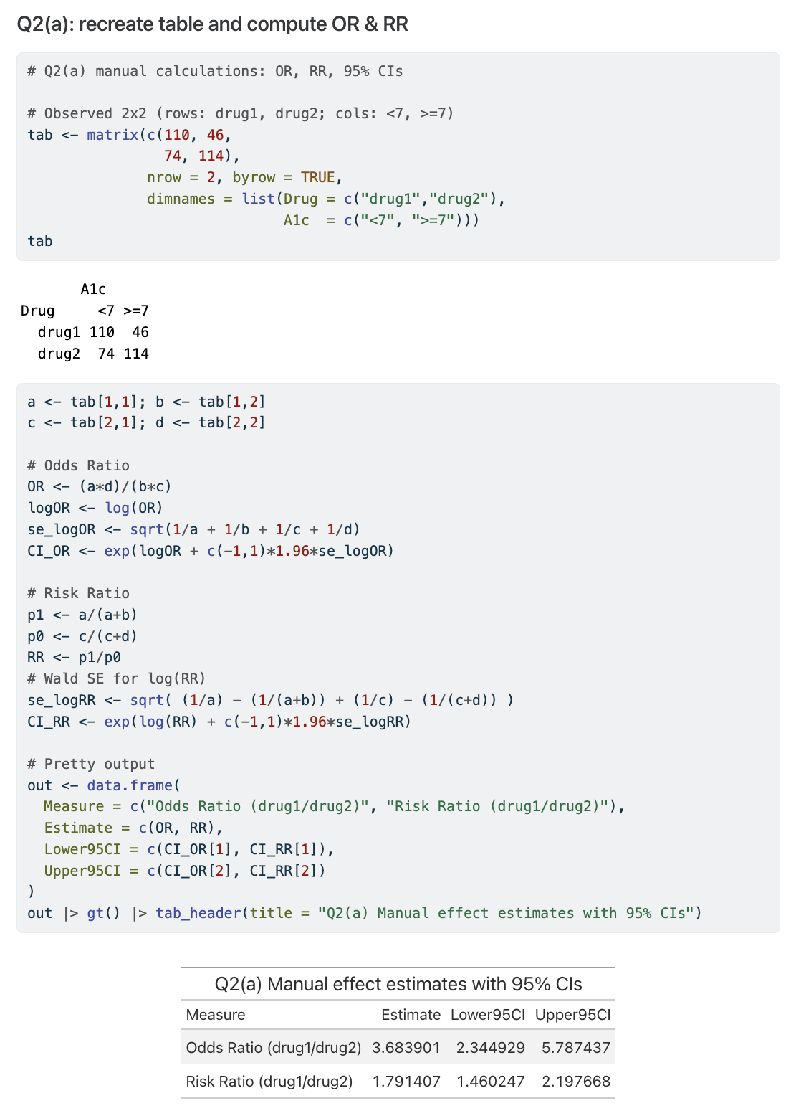
Answer: From the data provided, the odds ratio of achieving A1c < 7 with drug 1 vs. drug 2 is 3.684 (95% CI: 2.345-5.787) and the risk ratio is 1.791 (95% CI: 1.460-2.198). This means patients on drug 1 had about 3.7 times the odds and 1.8 times the probability of reaching the target A1c compared to those on drug 2. Both measures indicate a substantial advantage of drug 1 over drug 2.
  - If you come across data like this but don’t know how the sampling was designed (randomized trial or observational; if observational, case-control or cohort), is it better to use the odds ratio or the relative risk? Why (briefly)?

Answer: If the study design is unknown, the odds ratio (OR) is preferred because it can be calculated and interpreted for all major study designs, including case-control, cohort, and randomized trials. The relative risk (RR) requires measurable incidence or risk, which is only available in cohort or randomized designs, and cannot be directly calculated in case-control studies where sampling is based on outcome. Therefore, when the design is uncertain, the OR is the valid and universally applicable measure of association.

  - What is the null hypothesis, expressed in terms of whichever measure you chose in part b?

Answer:
Null hypothesis: The odds of having A1c < 7 are the same for Drug 1 and Drug 2 (OR = 1)

Alternative hypothesis: The odds of having A1c < 7 differ between Drug 1 and Drug 2 (OR != 1)

This frames the test as two-sided, looking for any difference in odds between the two drugs.

  - Fill in the following table with the expected counts, under the null hypothesis that there is no association between drug regimen and probability of A1c < 7 by the end of the study?

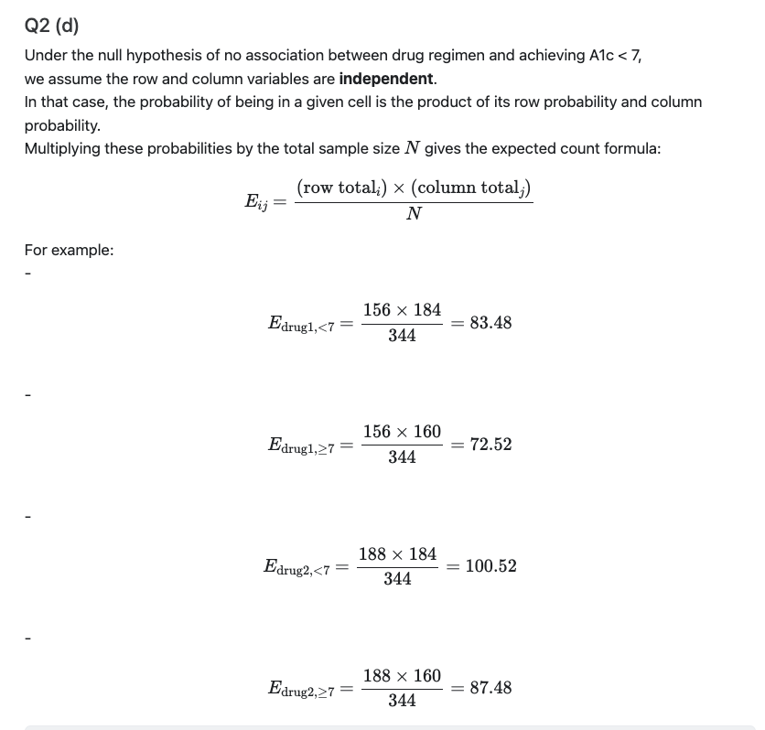

 | A1c < 7 at end of study | A1c ≥ 7 at end of study | Total
drug 1 | 83 | 73 | 156
drug 2 | 101 | 87 | 188
Total | 184 | 160 | 344

  - Using your answers to part (d) and the actual data shown at the top of the previous page, compute the chi-square statistic.
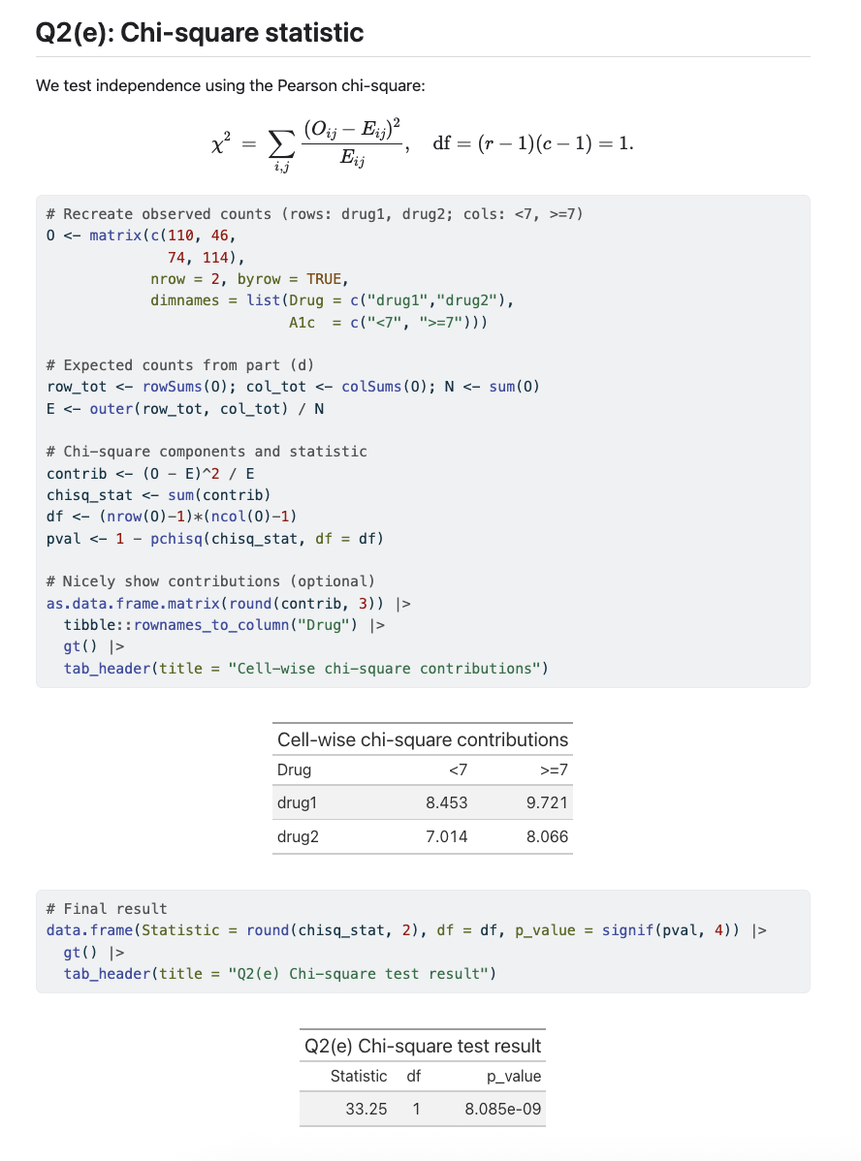
Interpretation: The chi-squared test yielded a statistic of 33.25 with 1 degree of freedom and a p-value of 8.09 * 10^-9, providing extremely strong evidence against the null hypothesis of independence between treatment group and achieving A1c < 7. This indicates a statistically significant association between drug type and glycemic control. In practical terms, the distribution of patients achieving A1c < 7 differs substantially between Drug 1 and Drug 2.

3. (10 pts) Continuing on the analysis from question 2, you decide to adjust for other variables in your analysis.

For your dependent (Y) variable, you code it 1 for each person where A1c is below 7 at the end of study and 0 if A1c is 7 or above. Then you build a model predicting a function of Y based on age, gender, BMI, and drug group in predicting the (log) odds that A1c count is below 7 by the end of the study.

a. What is the problem with using linear regression to analyze the data? What method could you use to analyze the data?

Answer: Using linear regression with a binary outcome is inappropriate because it assumes the outcome is continuous and normally distributed, which is not true for a 0/1 variable. Linear regression can also produce predicted probabilities less than 0 or greater than 1, which are not meaningful for a binary event. A more appropriate method is logistic regression, which models the log odds of the outcome, ensures predicted probabilities fall between 0 and 1, and uses the correct binomial error structure.

A few of the patients were very sick, and several died from diabetes-related complications before one year. Since the A1c count at one year was unavailable for these patients, one of the investigators proposed changing the analysis to compare the time to A1c count < 7 and censoring the patients who died or reached the end of the study without falling below 7.

b. What important assumption does this idea seem to violate? Explain (2-3 sentences maximum).

Answer: The proposed approach violates the non-informative censoring assumption in time-to-event analysis, which requires that the reason for censoring be unrelated to the likelihood of the event occurring. Here, patients who die from diabetes-related complications are censored but their censoring is related to the probability of achieving A1c < 7, making the censoring informative. This creates bias because the missing data (due to death) are directly linked to the outcome.

After hearing your explanation, the investigator decides to change the endpoint to time to event, where an event is any of kidney failure, heart attack stroke, or death.

c. What kind of test could she use to compare the time to event in the two treatment groups?

Answer: To compare time-to-event between the two treatment groups, the investigator could use a log-rank test, a non-parametric method for comparing Kaplan Meier survival curves. This test is standard for unadjusted comparisons in time-to-event analysis and assumes proportional hazards between groups.

4. (20 pts) True or false:

- If you regress x on y, the slope estimate will be the reciprocal of the slope estimate when you regress y on x.

FALSE. The slope in regression of x on y is not simply the reciprocal of the slope from y on x, unless the correlation is perfect (r = +/- 1). Ordinary least squares minimize residuals in one direction only.

- You should choose whether to do a test or a confidence interval and you should never do both on the same data.

FALSE. Tests and CI’s are complementary, the CI contains all values of the parameter that would not be rejected at the given significance level. It’s common to report both.

- The standard error helps us determine how far off an estimator might be from what it is trying to estimate.

TRUE. SE measures the expected variability of an estimator from the true population parameter due to sampling variability.

- The Wilcoxon test is appropriate for comparing two groups on a continuous outcome if you are worried about outliers.

TRUE. The Wilcoxon rank-sum (or Mann-Whitney) test is robust to outliers because it ranks data instead of using raw values.

- Sensitivity is more important than specificity if you want a diagnostic test to detect disease when it is present.

TRUE. Sensitivity is equal to the probability of testing positive given the disease is present. If the goal is to detect as many true cases as possible (screening), high sensitivity is prioritized.

- In univariate regression of y on x, the p-value will be the same if you test whether the slope is 0 or test whether the Pearson correlation is 0.

TRUE. In simple linear regression, the t-test for slope = 0 is equivalent to testing correlation of 0.

- If the p-value for a t-test comparing two means is 0.0001, there must be a large difference in means.

FALSE. A small p-value can result from a small difference if the sample size is large. P-values do not measure effect size directly.

- In logistic regression of y on x, the regression coefficient is the odds ratio for a 1 unit increase in x.

FALSE. The coefficient is the log odds ratio. The odds ratio itself is obtaining b exponentiating the coefficient.

- In survival analysis, censored observations should be eliminated before any analyses are conducted.

FALSE. Censored data are essential in survival analysis and are incorporated in models/tests; eliminating them biases results.

- If a 95% confidence interval for a regression slope is (-0.10, 0.40), then a 2-tailed test at alpha=0.05 would reject the null hypothesis that the true slope is 0.

FALSE. Since 0 is inside the CI, we fail to reject the H_0 at alpha = 0.05.
- (10 pts) Demographics and suspected Alzheimer’s disease risk factors were gathered on 96 healthy women and men ages 60 and up, who were given a cognitive test at baseline and then again one year later. These data were analyzed to examine the relationship between change on the cognitive test and other demographics including age, weight, height, sex, and family history of Alzheimers disease. The output for a linear regression predicting change in cognitive scores based on age is below.

> summary(lm(Score.Change ~ Age, temp))

Call:
lm(formula = Score.Change ~ Age, data = temp)

Residuals:
Min. 1Q Median 3Q Max
-13.04 -2.28 -1.41 0.49 12.32

Coefficients:
Estimate Std. Error t value Pr(>|t|)
(Intercept) -5.160 16.773 12.83 <2e-16***
Age -0.148 0.101 -1.48 0.17
---
Signif. codes: 0 ‘***’ 0.001 ‘**’ 0.01 ‘*’ 0.05 ‘.’ 0.1 ‘ ’ 1

Based on this model:

a. Write down the fitted equation from this model

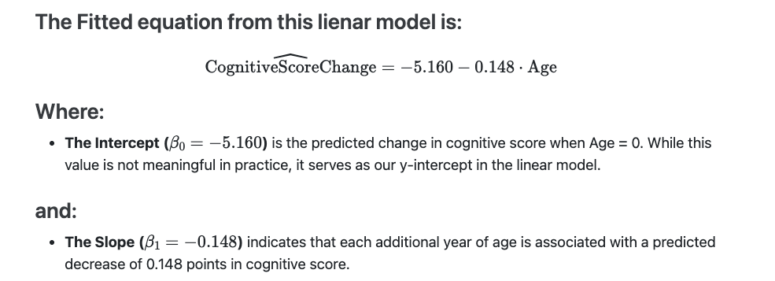

b. What is the difference in predicted change on the test between two people whose age differs by one year? Which one is predicted to have a more extreme change?
Answer: A one-year increase in age is associated with a predicted decrease of 0.148 points in cognitive score. The older person is expected to have the more extreme or lower score change.

c. Is there a significant linear relationship between age and change on the test based on this model?
Answer: The estimated slope for Age is -0.148 with a p-value of 0.17 from the summary result. Since this p-value is greater than the 0.05 significance level, we fail to reject the null hypothesis that the slope is zero. This indicates there is no statistically significant evidence of a linear relationship between age and change in cognitive score in this sample.

d. What is the difference in predicted change on the test between two people whose age differs by 10 years?
Answer: The slope of -0.148 indicates that each additional year of age is associated with a 0.148-point reduction in cognitive score. For a 10-year age difference we can multiply this factor by 10.

-0.148 x 10 = -1.48

As a result, the older person is predicted to have a cognitive score change that is 1.48 points lower than the younger person. However, because the slope was not statistically significant (p=0.17), this estimated difference should be interpreted with caution.

- (15 points) Multiple regression was used to build a second model to adjust for some of the demographic variables. The output from this multivariate model is below.

> summary(lm(Score.Change ~ Age + Sex + Weight + Family.History, temp))

Call:
lm(formula = Score.Change ~ Age+ Sex + Weight + Family.History, data = temp)

Residuals:
Min. 1Q Median 3Q Max
-13.04 -2.28 -1.41 0.49 12.32

Coefficients:
Estimate Std. Error t value Pr(>|t|)
(Intercept) -5.160 16.773 12.83 <2e-16***
Age -1.148 0.403 -2.85 0.004 **
Sex 2.529 1.879 1.35 0.177
Weight -0.794 0.251 -0.31 0.674
Family.History -8.148 3.532 2.31 0.010 *

Signif. codes: 0 ‘***’ 0.001 ‘**’ 0.01 ‘*’ 0.05 ‘.’ 0.1 ‘ ’ 1

Residual standard error: 28 on 95 degrees of freedom
Multiple R-squared 0.271, Adjusted R-squared: 0.24

F-statistic: 8.81 on 4 and 95 DF,p-value: 4.27e-06

Based on this model:

- What percentage of the variability in change in score is explained by its linear relationship with age, sex, weight and Family History?

Answer: The Multiple R^2 from this model is 0.271, meaning that 27.1% of the variability in change in cognitive score is explained by its linear relationship with age, sex, weight and family history of Alzheimer’s disease. This indicates that while the model explains a moderate portion of the variability, the majority (72.9%) is due to factors not included in the model or to random variation.

- What is the predicted difference in change in test score between two people of the same age, sex, and weight, with and without a family history of Alzheimer’s disease?
Answer: Among people with the same age, sex and weight, those with a family history of Alzheimer’s disease are predicted to have a change in cognitive score that is 8.148 points lower than without a family history. The negative sign indicates a greater decline in score for those with a family history.

- According to this model, is there a significant linear relationship between age and change in test score, after adjusting for sex, weight, and family history?
Answer: Yes. After adjusting for sex, weight and family history, age remains a statistically significant predictor of change in cognitive score (p= 0.004 < 0.05). This indicates that age is independently associated with the change in score, even when accounting for the other covariates in the model.

- Compare your answers to this question to question 5. Do you draw the same conclusions about the effect of weight when you adjust for other covariates as when you do not? How do you interpret this? (2-3 sentences maximum)
Answer: In both Question 5 (simple regression) and Question 6 (multiple regression), weight is not a statistically significant predictor of change in cognitive score. After adjusting for age, sex and family history, the p-value for weight (0.674) remains far above 0.05, confirming no evidence of an association. This suggests that weight likely has little to no independent effect on cognitive score change in this dataset.

7.( 15 points) You are a medical researcher, working with Ebola, Lassa fever, and related diseases. During a recent outbreak, you were able to collect data on Lassa fever patients, including whether they survived to be discharged or died in the hospital. When patients are present at the Treatment Unit, a sample of their blood is put into a RT-PCR assay to look for copies of the lassa virus. The primary readout from the RT-PCR is cycle threshold (CT)-- the number of cycles before the virus is detectable. Lower CT equates to more virus present, and therefore higher viral load.

Your hypothesis is that those who present with less virus (and therefore, higher CT values) are more likely to survive and recover than those who present with low CT values (and therefore higher viral load). You would like to design a study to test this, so you start by collecting data on a small number of patients as a pilot sample. You plan to analyze the data from this pilot study and use it to plan your larger study.

Your pilot data are saved on the class webpage in the data folder, under the name lassa.csv.

Variables include:
ID: Subject ID number
Died: an indicator of whether the patient died or not; 1=Died 0=Survived
Age: Age in years at time of admission
Gender: Male/Female
CT: cycle threshold; maximum 40.

Note: this is NOT real data, though it is inspired by real data, and by a real scientific hypothesis
- Briefly summarize the pilot data.
Outcome | n | mean_CT | sd_CT | median_CT | mean_age
Died | 4 | 25.50 | 4.65 | 25.5 | 33.13
Survived | 21 | 31.81 | 4.24 | 31.0 | 31.23
Interpretation: Survivors had higher CT values (lower viral load) than those who died. The group sizes are small and unequal, which guided the test selection in the next step.

- Does there seem to be a difference between mean CT values among those who died as compared to those who did not? Does it matter if you adjust for basic demographics (Age, Sex)?
Comparison | Estimate | CI_Lower | CI_Upper | p_value
Unadjusted (Welch t-test) | -6.31 | -13.26 | 0.64 | 0.065
Adjusted (Linear regression: +Age +Gender) | 7.54 | 3.26 | 11.82 | 0.001
Methodology:
The Welch’s t-test was used for the unadjusted comparison because it compares the means of two independent groups without assuming equal variances — a safer choice given our small and unequal group sizes. Linear regression was then used for the adjusted analysis to estimate the mean CT difference while controlling for age and sex, reducing confounding and isolating the association with survival.
Interpretation: The unadjusted result is borderline significant at α = 0.05. After adjustment, the mean CT difference is statistically significant, supporting the hypothesized relationship.
- This was a pilot study, and you were always planning to collect more data. Estimate the standard deviation (SD) of CT within each group (Alive/Dead) from this pilot data. Using the larger of the two estimated SDs, how many people would you need for each group (Alive/Dead) in order to have 90% power to see a true mean difference of 4 in CT values using a two-sided t-test? (Assume you want the same number in each group)

Appendix: Full R Code
library(dplyr); library(broom)

Attaching package: 'dplyr'
The following objects are masked from 'package:stats':
filter, lag
The following objects are masked from 'package:base':
intersect, setdiff, setequal, union
Warning: package 'broom' was built under R version 4.3.3
dat <- read.csv("lassa.csv") |>
mutate(
Outcome = factor(ifelse(Died == 1, "Died", "Survived")),
Gender = factor(ifelse(Female == 1, "Female", "Male"))
)
# 1) Summaries
summ_tab <- dat |>
group_by(Outcome) |>
summarise(
n = n(),
mean_CT = mean(CT, na.rm = TRUE),
sd_CT = sd(CT, na.rm = TRUE),
median_CT = median(CT, na.rm = TRUE),
mean_age = mean(Age, na.rm = TRUE),
.groups = "drop"
)
# 2) Unadjusted & adjusted
tt <- t.test(CT ~ Outcome, data = dat, var.equal = FALSE)
tt_row <- tidy(tt) |>
transmute(Comparison = "Unadjusted (Welch t-test)",
Estimate = estimate, CI_Lower = conf.low, CI_Upper = conf.high, p_value = p.value)
fit <- lm(CT ~ Outcome + Age + Gender, data = dat)
adj_row <- tidy(fit, conf.int = TRUE) |>
filter(term == "OutcomeSurvived") |>
transmute(Comparison = "Adjusted (Linear regression: +Age +Gender)",
Estimate = estimate, CI_Lower = conf.low, CI_Upper = conf.high, p_value = p.value)
# 3) Sample size calc
sds <- dat |>
group_by(Outcome) |>
summarise(sd_CT = sd(CT, na.rm = TRUE), .groups = "drop")
s_used <- max(sds$sd_CT)
alpha <- 0.05; z_alpha <- qnorm(1 - alpha/2); z_beta <- qnorm(0.90); Delta <- 4
n_per_group <- ceiling(2 * ((z_alpha + z_beta)^2) * (s_used^2) / (Delta^2))

